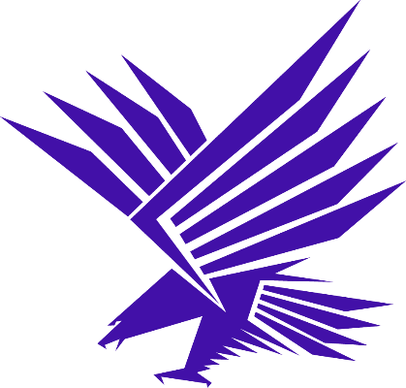
Anacortes Seahawks Sailing Team
Middle School Team
Spring 2024

Contact:

Chloe Cook - Middle School Head Coach
Contact Chloe through TeamSnap

Elise Murphy - AWA Sailing Programs Manager
program@anacorteswaterfront.org
360-391-0904

About the Team:
Our Middle School team is designed to introduce young sailors to racing concepts so they are ready to feed into the High School Sailing Team when they enter High School. Sailors will be sailing in single-handed (one person) sailboats, so participation in a sailing class or experience sailing with family in a sailing dinghy is required for joining the Middle School team. The sailing team is not a substitute for our learn to sail classes. Sailors should have the ability to perform basic boat handling maneuvers like tacking and jibing and have an understanding of the sailor's wind clock and parts of a sailboat. The Middle School sailing team will build off these beginner skills and work towards more advanced sailing techniques and basic racing skills.

In order to provide more sailing time for each member of the team we have a cap of 15 sailors for our Middle School Team. Priority will be given to returning Middle School Sailing Team members, then students who participated in AWAs Intro to Racing Middle School Class and if space is still available students who have completed an Intermediate Learn to Sail Class through AWA.

Parent/Sailor Pre Season Meeting: Tuesday March 26th, 2024 at 5:30PM AWA Sailing Center at Seafarers Park

We will have the gear bin available for anyone who wants to borrow gear for the season.

Practices:
- Middle School practices are on Thursdays from 3:15PM - 6PM from April 11th through June 13th, 2024.
- Middle School practices will be run out of the AWA Sailing Center located at the Seafarers Park Building. (601 Seafarers Park Way, Anaocrtes, WA 98221)
- If the weather is not favorable for sailing we may have a shorter classroom time in the sailing center kiosk or a notice that practice is canceled will be sent out to the team over email.

Regattas:
- May 18th, 2024 - Friday Harbor Tera Regatta
- June 8th, 2024 - Anacortes Middle School Regatta
- Additional Middle School regattas around the PNW may be announced as they are scheduled

Gear:
Required Gear
- Type III Coast Guard Approved PFD
- Full Wetsuit (at least 3.2mm thick)
  - Plan like you are going to capsize every practice. Make sure your wetsuit is comfortable, fits well and will keep you warm.
- Waterproof whistle (Attached to PFD)
Recommended Gear
- Gloves (fingerless or full)
  - Sailing specific gloves or non cotton gardening/work gloves work
- Sailing Booties, waterproof boots, shoes or sneakers with non- marking soles
  - If you don’t have sailing booties waterproof socks like Sealskinz are a good option with tennis shoes
- Wool or fleeces layers, jackets, hats and socks.
  - In general, extra layers are always good
  - Avoid cotton that isn't warm when wet.
- Sunglasses with Croaky
  - Polarized is recommended to protect your eyes and helpful to see the puffs on the water
- Gear Bag (doesn’t need to be waterproof but you might fill it up with wet gear)
Where to buy
- West Marine - Anacortes (Tell them you are on the team for a discount)
- Anacortes Dive Shop - good source for wetsuits
- Fisheries Supply - Seattle
- LFS- Bellingham

Bring extra change of dry clothes to all practices, expect to get wet!!

Safety:
Safety is the #1 priority for our Team. We have qualified coaches and volunteers who act as on-water safety for the sailors. It is important to note: every sailor is responsible for their own safety.

Sailing is fun and it also involves risk. We ask sailors to listen to their coaches at all times, no rough-housing, no running on docks, etc. Life jackets must be worn at all times on the dock and on the water.

Capsizing- Capsizing is a part of dinghy racing and every sailor will capsize during the season. In the first month we will be doing mandatory capsize drills on a weather appropriate day to ensure each sailor knows how to perform a capsize recovery. You should be dressed appropriately for a capsize every day.

Wind speed and wave conditions will be used to determine who will be able to sail each practice. We will still sail in the rain so sailors should dress appropriately to stay warm in all conditions.

Team Dues:
The team dues for the fall season are $250. We have scholarships available so please reach out to the coach if the team dues are a detriment to joining the team. Donations help us provide scholarships to eligible sailors so they can participate on the team. Please consider making a donation on the Sailing Team page to help make the sailing team accessible to everyone regardless of financial means.

Registration:
Sailors must have registration and a liability waiver complete before they can participate on the water.

AWA Registration:
- Fill out the Spring 2024 Sailing Team Survey: Middle School Sailing Team Spring 2024 Registration (google.com)
- New sailors: Fill out waiver form: AWA Liability Waiver Form
- Pay the team dues Sailing Team Dues (square.site)

